**Data Collection and Preprocessing Phase**

|  |  |
| --- | --- |
| **Section** | **Description** |
| Data Overview | DIMENSIONS=1453 ROWS X 15COLUMNS DESCRIPTIVE ANALYSIS: |

|  |  |
| --- | --- |
| Date | 15 July 2024 |
| Team ID | 739834 |
| Project Title | MARKET SEGMENTATION ANALYSIS |
| Maximum Marks | 6 Marks |

**Data Exploration and Preprocessing Template**

Identifies data sources, assesses quality issues like missing values and duplicates, and implements resolution plans to ensure accurate and reliable analysis.

|  |  |
| --- | --- |
| Univariate Analysis |  |

|  |  |
| --- | --- |
|  |  |

|  |  |
| --- | --- |
|  |  |

|  |  |
| --- | --- |
|  |  |

|  |  |
| --- | --- |
| Bivariate Analysis |  |

|  |  |
| --- | --- |
|  |  |
| Multivariate Analysis | . |

Outliers and Anomalies

**Data Preprocessing Code Screenshots**

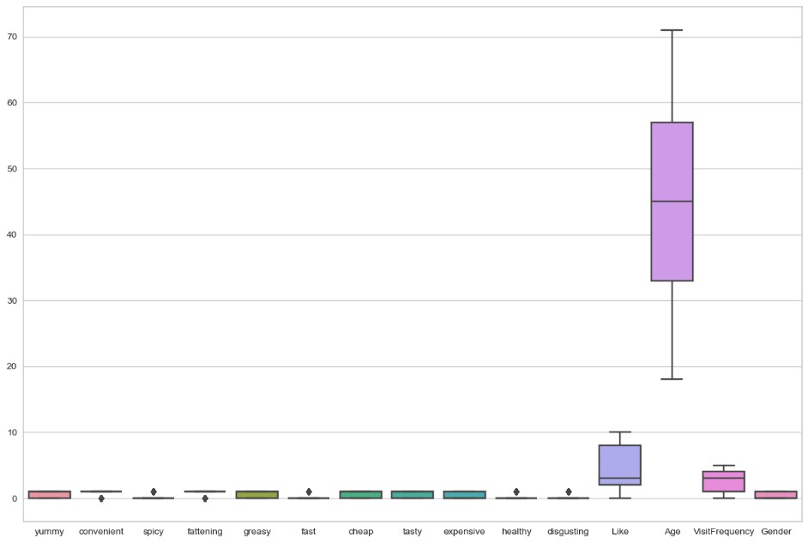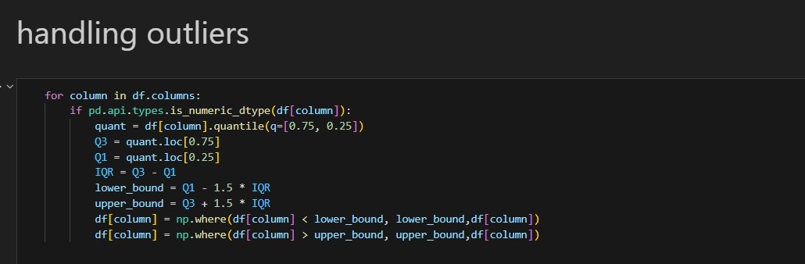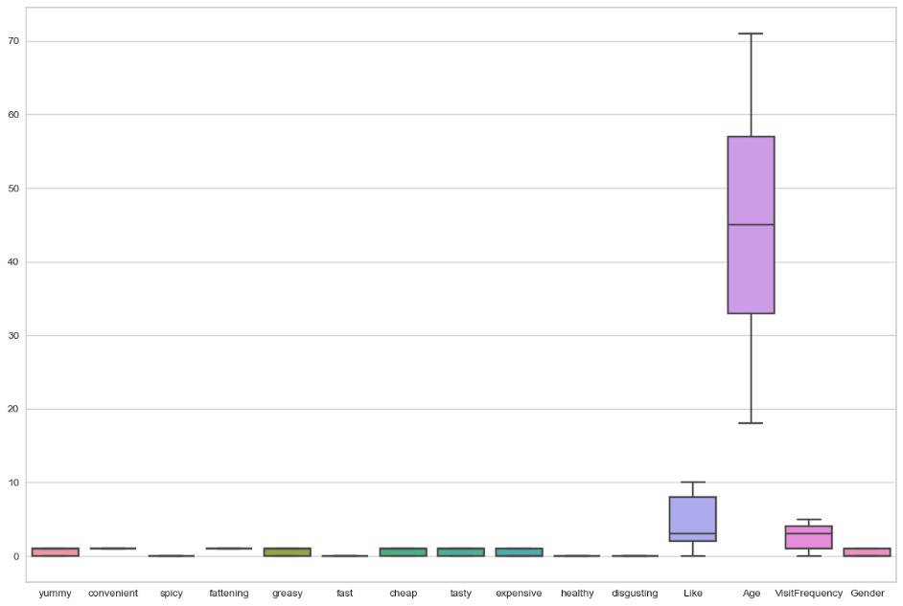

|  |  |
| --- | --- |
| Loading Data |  |
| Handling Missing Data | No missing values found |
| Data Transformation |  |
| Feature Engineering | Attached the codes in final documentation |

|  |  |
| --- | --- |
| Save Processed Data | - |